

**Genius Reply Bot**

**Robotic Process Automation**

**Name :** Anubhav Prasad

**Roll No. :** 29

**Regestration No. :** 12216008

**Mentor :** Isha(UID : 28828)

**Submission Date** : 11th November 2024

**Introduction:**

The **Genius Bot** project automates the process of searching for shops on Google, extracting their reviews, and generating automated replies to these reviews using **GPT**. This bot is designed to help businesses or clients enhance their online reputation by engaging with customers through automated responses. Whether you're using the **Community version** or **Enterprise version**, the solution is scalable and simple to implement. The bot extracts data from an Excel file, processes it, and replies with personalized messages using GPT to engage customers effectively.

**Project Objectives:**

* **i.** Automate the process of retrieving Google reviews for specified shops.
* **ii.** Use GPT to generate personalized responses to the reviews.
* **iii.** Store the review details and corresponding responses in an Excel file.
* **iv.** Minimize manual effort by integrating with Google and GPT for automated customer engagement.
* **v.** Deliver a high Return on Investment (ROI) by streamlining the review response process and improving customer interaction.

**Process Flow:**

1. **Data Input:** Open the Excel file that contains the shop names and locations.
   * Shop names and locations are retrieved from the **Excel file** to search for reviews on Google.
2. **Search Google:** The bot opens the Google search page and uses the shop name and location to search for relevant reviews.
3. **Extract Reviews:** The bot extracts the reviews for the specified shop.
4. **Generate Responses:** Using **GPT**, the bot generates personalized responses for the extracted reviews.
5. **Store Data:** The bot stores the reviews and the corresponding responses in an Excel sheet for further analysis and reporting.
6. **Automation:** The bot ensures the process is fully automated from searching to replying, and the results are saved in real-time.

**Steps:**

1. Open the excel file in read- write mode. Then extract B1 cell from the excel which stores the shop name and store it in a variable **$strShopName$.**

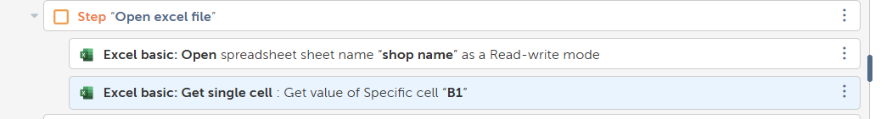

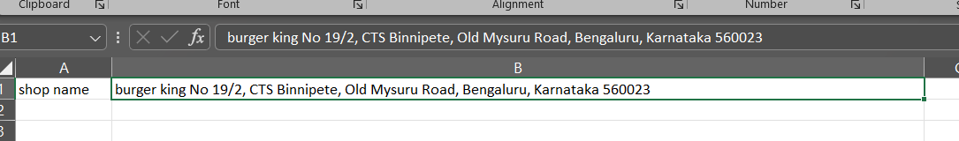

**Excel file which have the shop name**

1. Open the chrome browser or any other browser . Then search for the webpage “www.[**google.com**](http://www.google.com)”**.** Wait for the window to open.

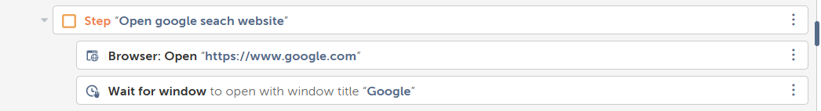

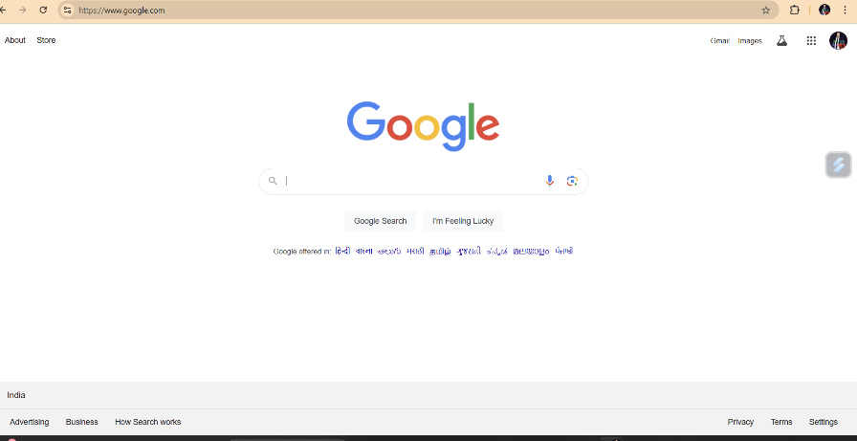

This window will appear

1. Search the shop name in google:
   * + Capture the search bar using recorder and set the correct DOMXpath.
     + Then choose the action “set text”.
     + Search the google reviews for a particular shop name and click enter.

Eg: **$strShopName$** Google Review **$String:Enter$**

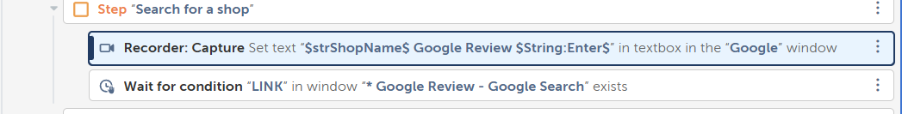

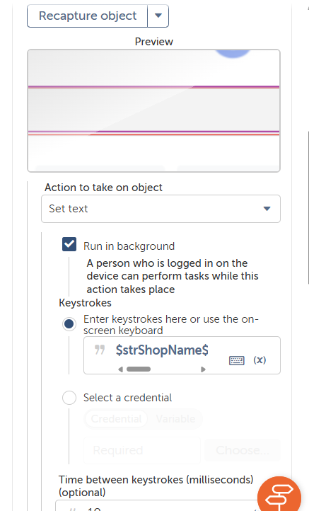

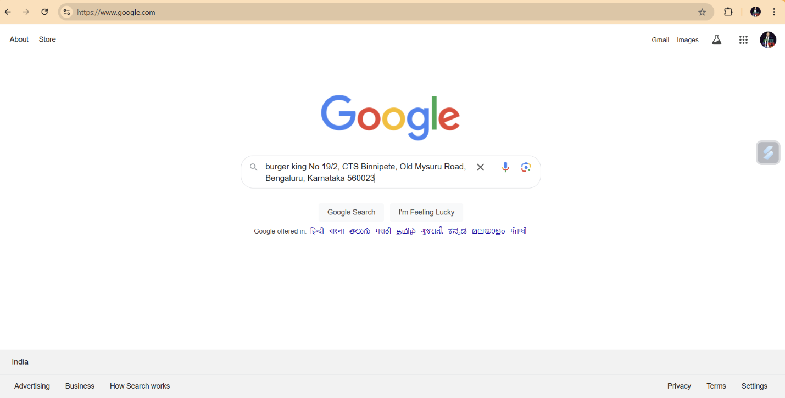

**4.Extracting the review:**

- After searching the shop on google review ,we need to click on the google review .To extract the review use the correct DOMXpath .

Eg: (//*[@data-async-trigger="reviewDialog"])[1]

- Then a new window will open containing all the google review . Again get the DOMXpath of all the reviews. Eg: (//*[@class="review-full-text"])[$counter$].

- Use loop to extract multiple reviews and store it in a variable $strReview$.

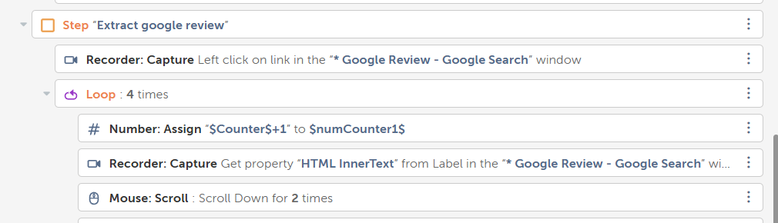

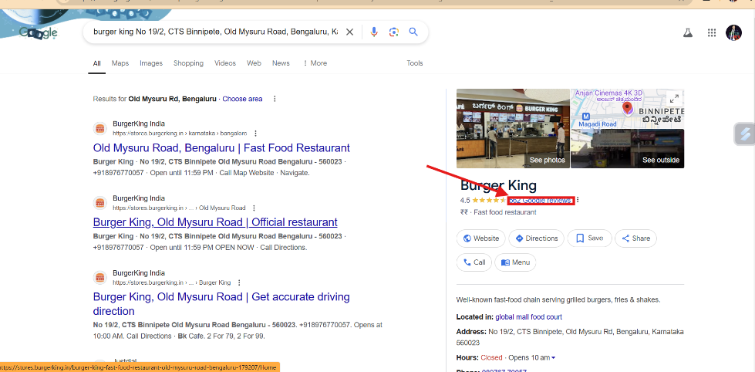

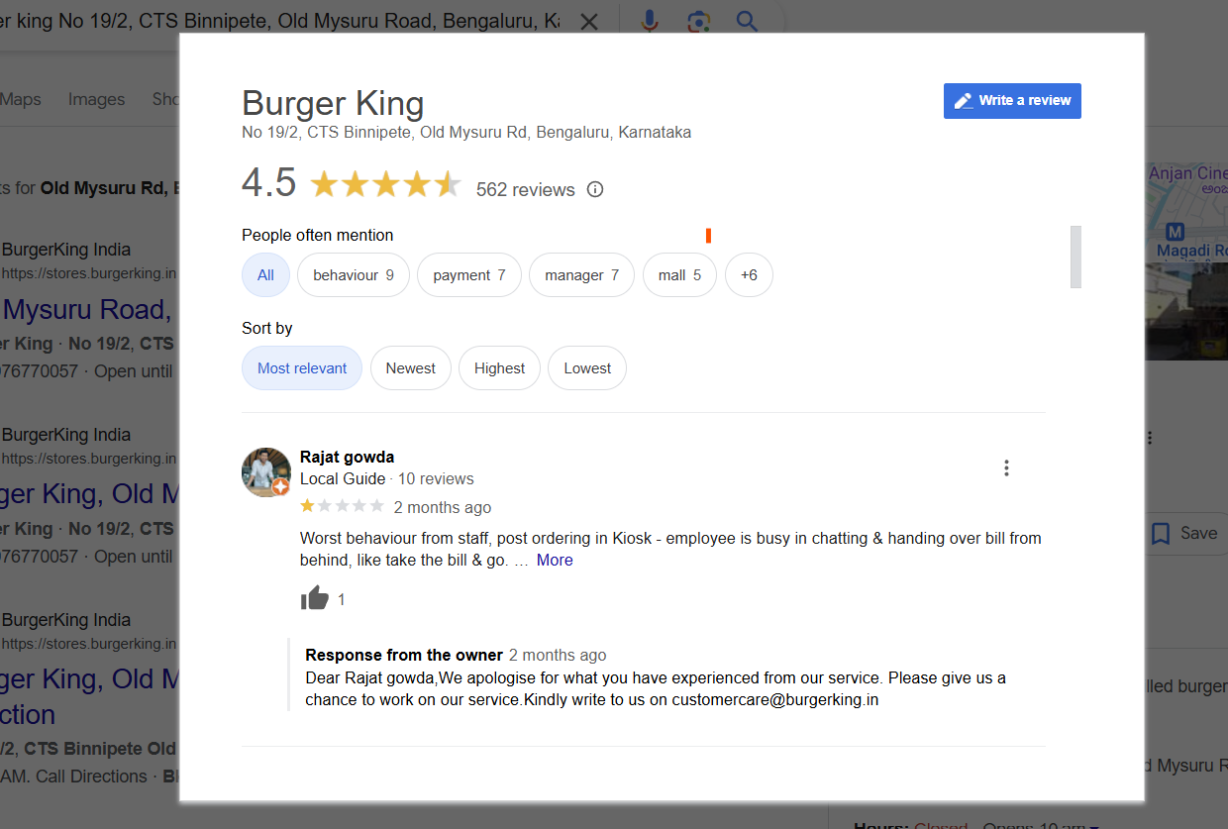

**5.Integrate with the Chatgpt:**

-Open the chatgpt.com in the new tab in chrome browser . Wait for the browser to open using “wait” action.

-Capture the prompt box using universal recorder and using the property “set text” set the prompt like this ***“Owner reply for Google review in 100 words: $strReview$ [ENTER]”.***

***-*** As the gpt give reply, the bot will wait for the copy button to appear and it will copy the review into your clipboard.

- Then you just need to assign the clipboard content to variable $gptOutput$ using “assign:$Clipboard:Clipboard$” action.

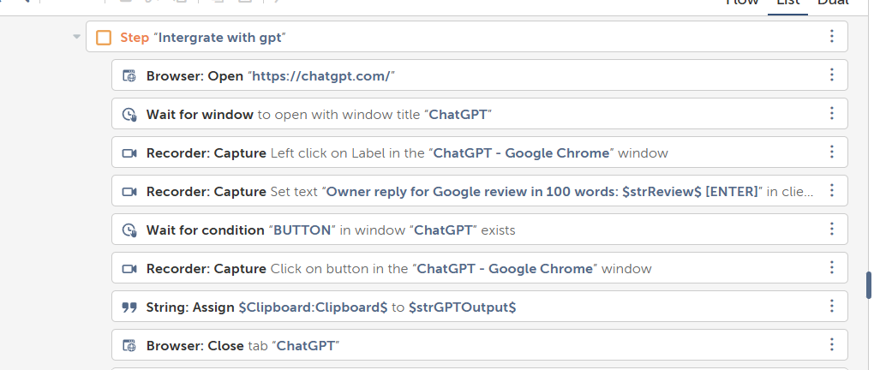

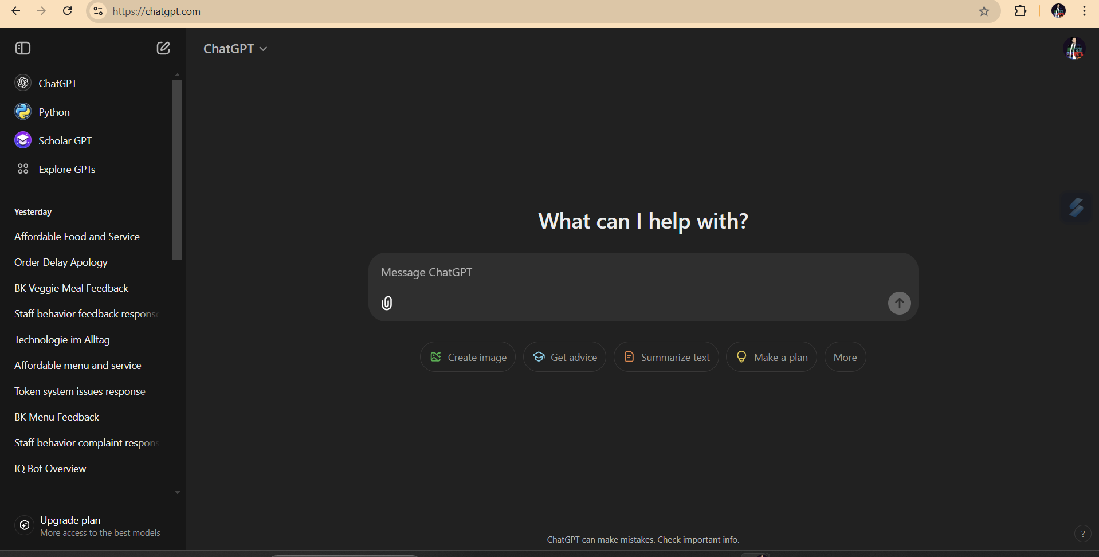

Bot wait for the window to appear.

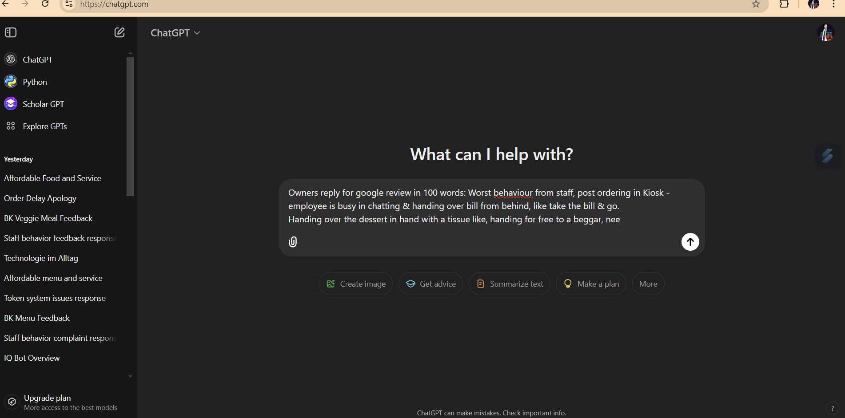

Here the bot set the given prompt in gpt.

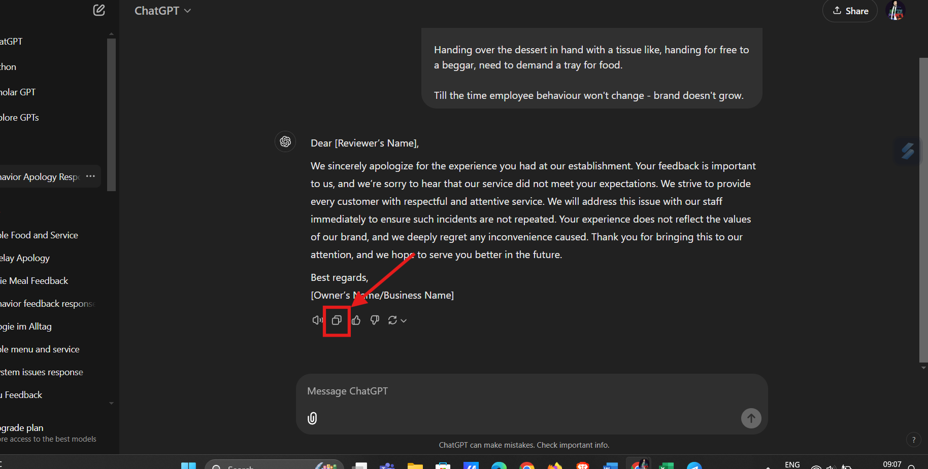

Bot clicks on copy button

**6.Get back the review in Excel:**

* + - The bot will switch the excel sheet to “*review and reply*” using “Switch “ action.
    - Then it start filling the excel cells .It stores both customer’s review and owner’s reply generated by chatgpt.

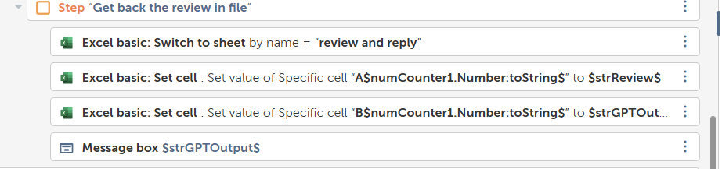



Bot switched to a new empty sheet.

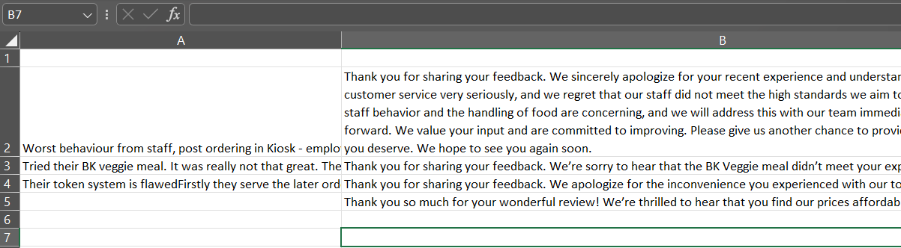

Bot started filling the reviews and reply in excel sheet.

**Tools and Technologies Used:**

* **Automation Anywhere:** Used for creating and executing the automation workflows to interact with Google, extract reviews, and manage Excel data.
* **Excel:** Acts as a data storage solution to manage shop names, locations, reviews, and automated responses.
* **GPT Integration:** GPT is used to generate relevant, personalized responses to the customer reviews.
* **Google:** The bot accesses Google to search for shop names and retrieve reviews.

**Challenges and Solutions:**

1. **Google Review Extraction:**
   * **Challenge:** Extracting reviews from Google requires navigating complex webpage structures and handling dynamic content loading.
   * **Solution:** The bot employs automated web scraping techniques to extract the reviews efficiently, ensuring that it can interact with Google pages dynamically. By using the **Universal Recorder** in Automation Anywhere, the bot mimics human actions to extract the data correctly.
2. **Handling Dynamic Inputs:**
   * **Challenge:** Shops may be located in various locations, requiring dynamic location input for Google searches.
   * **Solution:** The bot reads shop names and locations from the Excel file, allowing it to handle multiple inputs without manual intervention. It also allows the option for user input through prompts for flexibility.
3. **Error Handling:**
   * **Challenge:** Errors may occur due to connection issues, page load failures, or unexpected input formats.
   * **Solution:** The bot integrates **try-catch error handling** to ensure that any unexpected errors are logged and addressed without halting the execution process. This improves reliability and reduces downtime.

**Screenshots:**

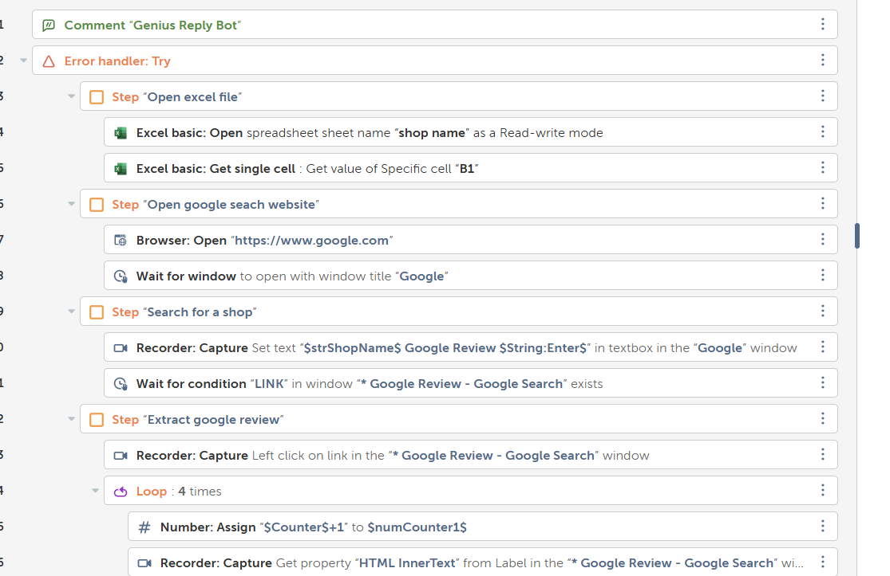

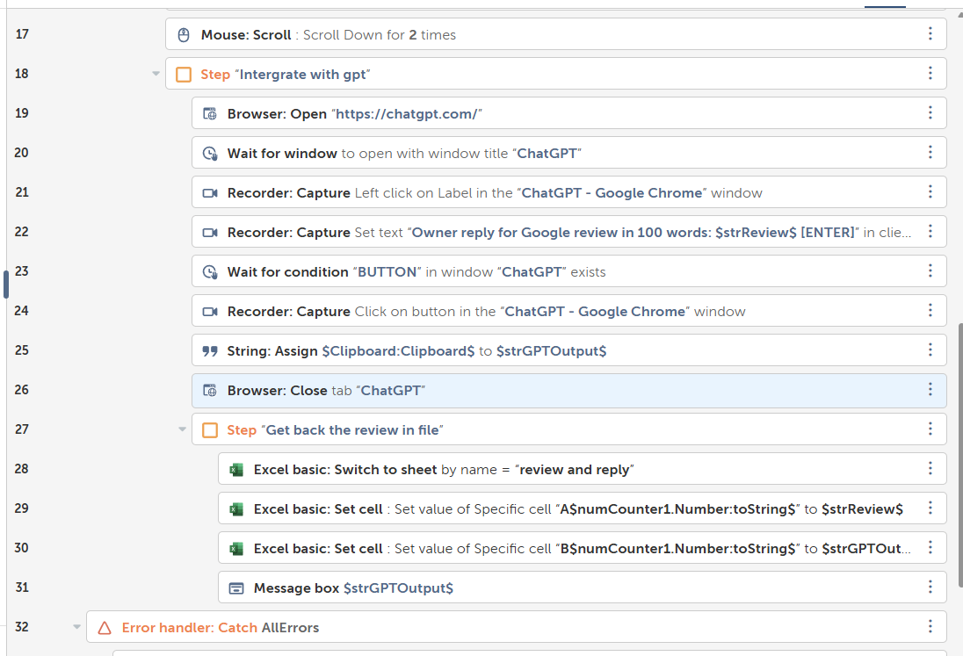

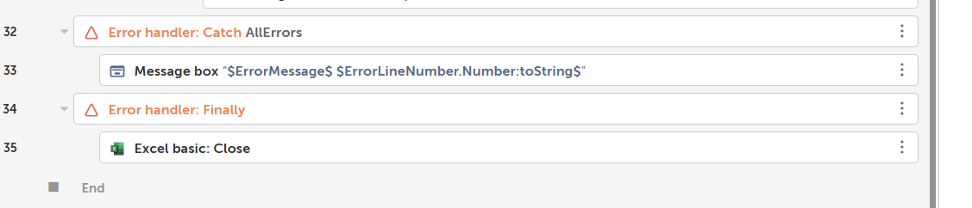

**Results and Benefits:**

* **Single Input:** Here only shop name and address is only given . Rest all the things bot do it automatically.
* **Time-saving:** The automation eliminates the need for manual extraction and reply generation, saving time for businesses to focus on core activities.
* **Increased Customer Engagement:** The bot's automated responses ensure timely engagement with customers, enhancing customer satisfaction and potentially improving business ratings.
* **Consistent Accuracy:** By using GPT, the responses are personalized and accurate, maintaining a consistent tone aligned with the business’s voice.
* **Enhanced ROI:** The bot automates processes that traditionally require significant manpower, leading to reduced operational costs and higher customer engagement, resulting in improved ROI.

**Future Scope and Improvements:**

1. **Dynamic Review Filtering:**
   * The bot could be improved to filter reviews based on ratings (e.g., respond differently to positive vs. negative reviews), providing more tailored engagement with customers.
2. **Integration with Multiple Review Platforms:**
   * Expanding the bot’s capabilities to pull reviews from multiple platforms like Yelp, Facebook, and TripAdvisor would create a more comprehensive solution for businesses that have a presence across various review sites.
3. **Response Personalization:**
   * Future enhancements could involve analyzing sentiment in reviews, allowing GPT to generate even more personalized and contextually relevant replies based on the emotional tone of the review.
4. **User Interface (UI):**
   * A user-friendly interface could be developed for business owners or clients to easily configure and monitor the bot’s activities, such as selecting shops, entering locations, and managing responses.

**Conclusion:**

The **Genius Bot** automates the process of extracting Google reviews and generating responses, offering a seamless solution for businesses looking to engage with customers efficiently. By integrating GPT and leveraging tools like Automation Anywhere, the bot not only saves time but also ensures that customer feedback is handled in a timely and consistent manner, providing a higher return on investment for businesses. Future improvements could expand its functionality, allowing for greater customization and multi-platform integration, making it an even more valuable tool for businesses aiming to improve customer engagement and online reputation.